مسابقة رمضان السنوية
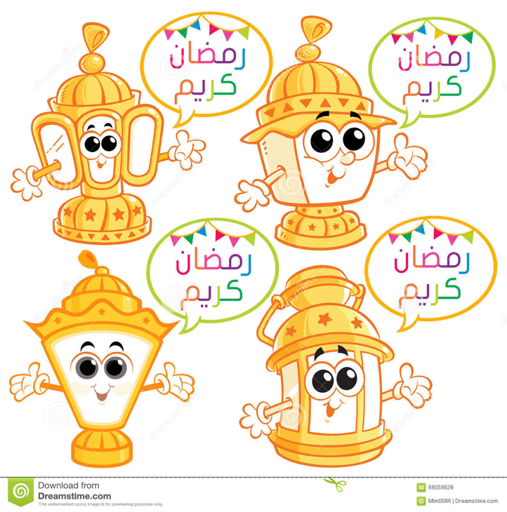
Annual Ramadan General Knowledge Competition
2020
Submit your packet to Imam before deadline 27rd RAMADAN (May 19th, Tuesday, 3PM)

Name: _______________________________________
Address: ______________________________________
Phone number: _________________________________

How to submit?
Please email/text your responses to
Syed Faizan: syedfaizan0291@gmail.com, 9722739045
Syed Zafar: syedzafarshah6@gmail.com, 4804340584
You can also hand over your responses to Imam in office at masjid

Random Questions
1) How many names of books mentioned in the Quran? عدد الكتب السماوية التى ورد ذكرها في القرآن؟
_____________________________________________________________________________
2) What was the origin of the Sushi plate اصل طبق السوشي
_____________________________________________________________________________
3) Who started gathering the Mushaf to get the Quran all in one book? بدأ بجمع المصحف في عهد أبو بكر
__________________________________________________________________________________
4) The word “AlMeharb” was mentioned in the Quran how many times? ورد كلمة المحراب في القران؟
_________________________________________________________________________________
Animal Trivia
5) Which animal has the highest blood pressure? ما هو الحيوان الذى لدية اعلى ضغط دموي
__________________________________________________________________________________________________________________________________________________________________________
6) Which animal does not drink water? اي حيوان لا يشرب الماء؟
__________________________________________________________________________________________________________________________________________________________________________
7) A honey bee has how many eyes? كم عين لدي النحلة ؟
_____________________________________________________________________________________
8) In which surah and ayah was a lion mentioned? في اي سورة ذكر الأسد؟
_____________________________________________________________________________________
9) Which surah mentioned a frog? And what was the ayah? What was the story?
ما السورة التي ذكر فيها الضفدع؟ و ما القصة؟
____________________________________________________________________________________
10) How many times was “whale” mentioned in the Quran? كم مرة ذكر “حوت” في القرآن؟
_________________________________________________________________________________________________________________________________________________________________________

Questions about Fasting
11) What is the meaning of fasting “siyam” lingustistically? معنى الصيام لغويا
__________________________________________________________________________________________________________________________________________________________________________
12) What does fasting “Siyam” mean islamically? معنى الصيام شرعا؟
__________________________________________________________________________________________________________________________________________________________________________
13) What are some benefits of fasting? ما بعض فوائد الصيام صحيا؟
__________________________________________________________________________________________________________________________________________________________________________
14) What are the ruling regarding swallowing mucus in your mouth? ما حكم بلع البلغم للصائم ؟
____________________________________________________________________________________
15) The idea of making a fanoos started in which era? فكرة فانوس رمضان جاءت في اي عهد؟
_____________________________________________________________________________________
Companions of the Prophet
16) Seven siblings from the Companions who are they? سبعة اخوة من الصحابة فمن هم
__________________________________________________________________________________________________________________________________________________________________________
17) First companion born in Islam? اول صحابي ولد في الإسلام
_____________________________________________________________________________________
18) Name the ten companions that were giving glad tidings of paradise (without naming the four caliphates)? من هم العشر المبشرين بالجنة ( من غير ذكر الخلفاء الراشدين
__________________________________________________________________________________________________________________________________________________________________________
19) Why was Abu Bakr AL SADIQ named as such? لماذا سمي أبو بكر الصديق بالصديق ؟
_____________________________________________________________________________________

20) Which companion’s supplication is always answered? من الصحابي الذي كان مستجاب الدعوه ؟
_____________________________________________________________________________________

Biography of the Prophet

21) Name all the battles that the Prophet peace be upon him witnessed? ما هي الغزوات التي شاهدها الرسول
__________________________________________________________________________________________________________________________________________________________________________
22) Name all of the Prophet’s wives? من هم ازواج سيدنا محمد صلى الله عليه و سلم؟
__________________________________________________________________________________________________________________________________________________________________________
23) Name all of Prophet’s daughter من هم بنات النبي صلى الله عليه و سلم
__________________________ _______________________
__________________________ ________________________
24) How many Hajj did the Prophet Muhammed Perform? كم حجة حج النبي وكم عمرة اعتمر ؟

25) ) How many messengers did the Prophet Muhammed send to rely information about Islam?
كم عدد السرايا التي أرسلها الرسول صلى الله عليه وسلم ؟

Who was the first....
26) First to fight with a sword? اول من قاتل بالسيف
27) Who was the first to travel in Islam?- من أول سفير بالاسلام ؟

28) Who was the first to scarifice in Islam? من أول فدائي يالاسلام ؟

29) Who was the first to set up the Hijiri Calendar? من أول من وضع التقويم الهجري ؟
30) Who was the first to ride a horse? اول من ركب الخيل؟

ماذا فعلت مختلف فى رمضان هذا العام؟
What did you do differently this Ramadan?
__________________________________________________________________________________________________________________________________________________________________________
__________________________________________________________________________________________________________________________________________________________________________
__________________________________________________________________________________________________________________________________________________________________________
__________________________________________________________________________________________________________________________________________________________________________
__________________________________________________________________________________________________________________________________________________________________________
__________________________________________________________________________________________________________________________________________________________________________
__________________________________________________________________________________________________________________________________________________________________________
__________________________________________________________________________________________________________________________________________________________________________
__________________________________________________________________________________________________________________________________________________________________________

